**Caring/ Nurturing Game Demographics**

**Gender Mood board**

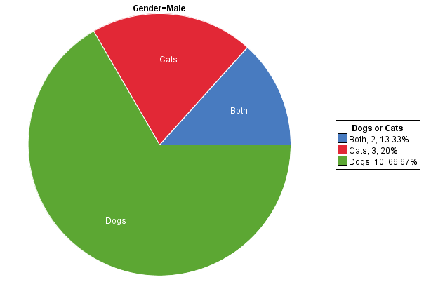

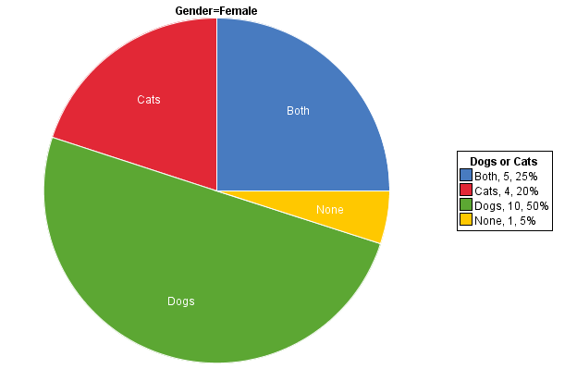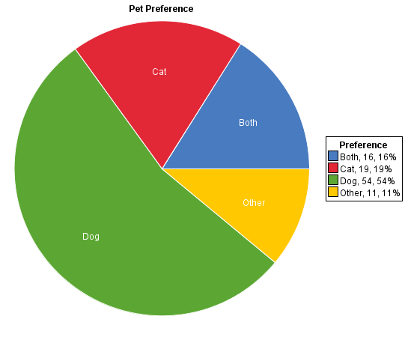

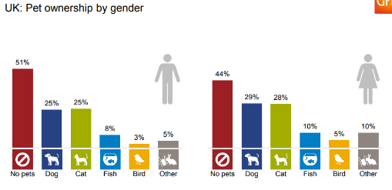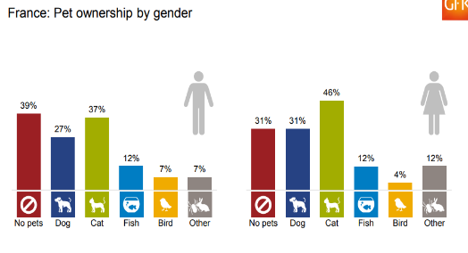

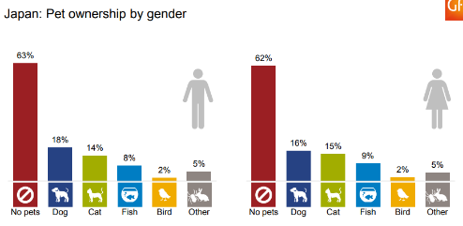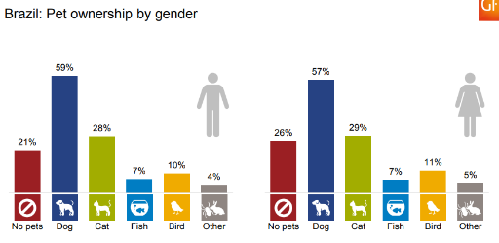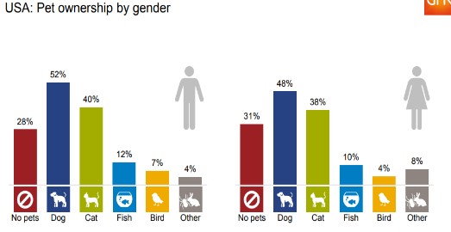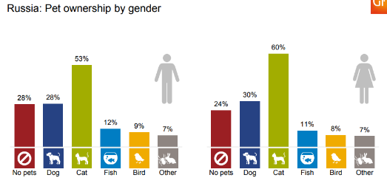

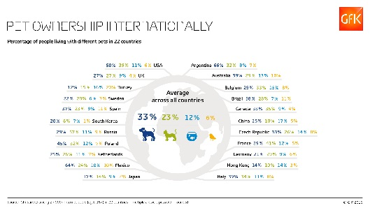**Pet ownership in households Mood board**

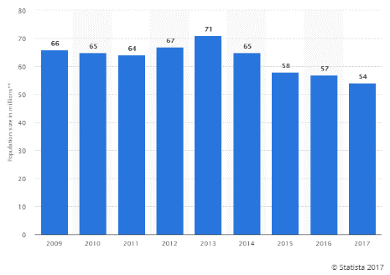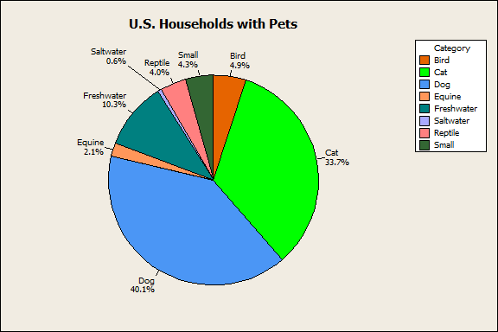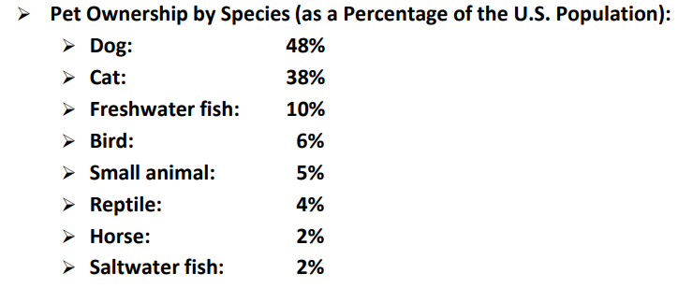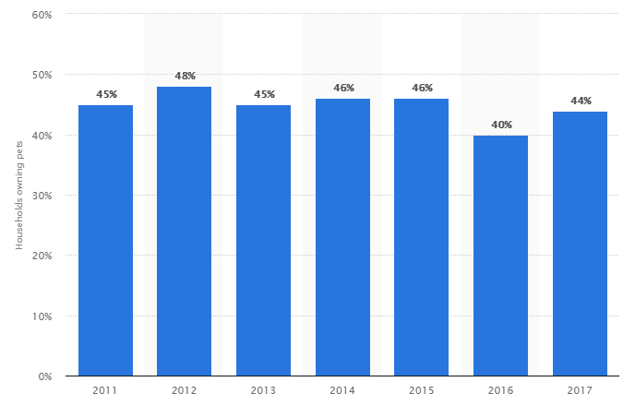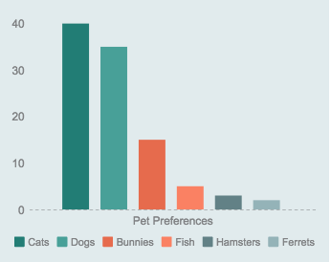

**Animal Nurturing Games and age range.**

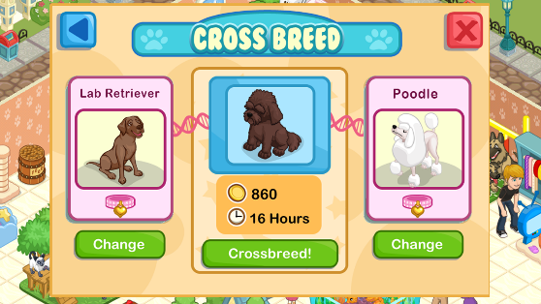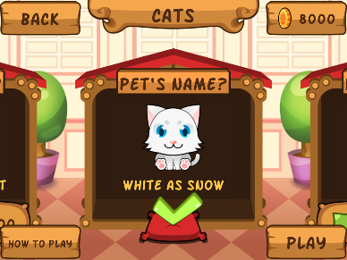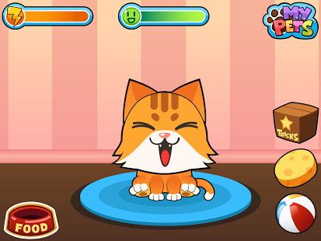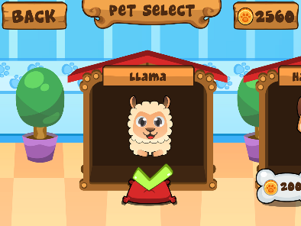

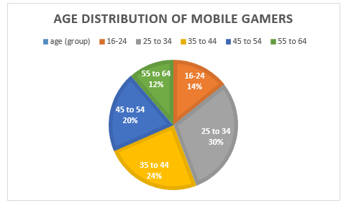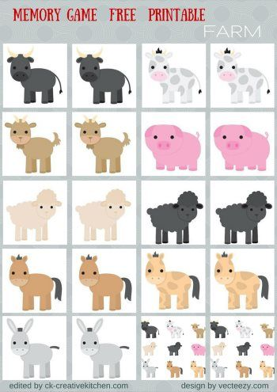

**Interesting facts**

* 60% of Women say dogs are more affectionate than men. 70% say they are more easy going then men, 63% say dogs are more loyal than men and 75% say dogs are more reliable
* 56% of 27,000 people in 22 countries have at least one pet
* 40% of registered pets in the uk are registered to women and 21.5% to men.
* The average cost to own a puppy for one year is $2950 for both male and female compared to $1900 for kittens.
* Men prefer cats as pets where women prefer dogs over cats.

**References towards animal nurturing target audience**

* 2017, S. (2017). *Pet ownership in the UK 2009-2017 | Survey*. [online] Statista. Available at: <https://www.statista.com/statistics/308235/estimated-pet-ownership-in-the-united-kingdom-uk/> [Accessed 26 Oct. 2017].
* americanpetproducts. (2017). *The 2017-2018 APPA National Pet Owners Survey Debut*. [online] Available at: <http://americanpetproducts.org/Uploads/MemServices/GPE2017_NPOS_Seminar.pdf> [Accessed 26 Oct. 2017].
* Apps, F. (2017). *Loy 🐾 Jogo Bichinho Virtual*. [online] Play.google.com. Available at: <https://play.google.com/store/apps/details?id=com.frojo.loy.android&hl=pt-br> [Accessed 27 Oct. 2017].
* Fryrear, A. (2017). *Survey Results: Reporting via Pie Charts or Bar Graphs*. [online] SurveyGizmo. Available at: <https://www.surveygizmo.com/survey-blog/pie-chart-or-bar-graph/> [Accessed 26 Oct. 2017].
* Games, T. (2017). [online] Play.google.com. Available at: <https://play.google.com/store/apps/details?id=br.com.tapps.myvirtualpet&hl=pt_BR> [Accessed 27 Oct. 2017].
* Games, T. (2017). *Pet Shop Story*. [online] Play.google.com. Available at: <https://play.google.com/store/apps/details?id=com.teamlava.petshop&hl=en> [Accessed 27 Oct. 2017].
* Gfk. (2017). *International average: what pets do you have living with you?*. [online] Available at: <http://www.gfk.com/insights/infographic/international-average-what-pets-do-you-have-living-with-you/> [Accessed 26 Oct. 2017].
* Gfk. (2017). *Pet ownership*. [online] Available at: <https://www.gfk.com/fileadmin/user_upload/country_one_pager/NL/documents/Global-GfK-survey_Pet-Ownership_2016.pdf> [Accessed 26 Oct. 2017].
* Learn4good.com. (2017). *Pet Games Online free,virtual fun for kids,girls*. [online] Available at: <https://www.learn4good.com/games/pet.htm> [Accessed 27 Oct. 2017].
* Number of pet animals in Europe in 2016, S. (2017). *animal type (in 1000s) European pet population 2016, by animal | Statistic*. [online] Statista. Available at: <https://www.statista.com/statistics/453880/pet-population-europe-by-animal/> [Accessed 26 Oct. 2017].
* PFMA. (2017). *Pet Population 2017*. [online] Available at: https://www.pfma.org.uk/pet-population-2017 [Accessed 26 Oct. 2017].
* Pinterest. (2017). *Preschool Zoo Activities: Animal Match Game Printable*. [online] Available at: <https://www.pinterest.com/pin/94786767135600370/> [Accessed 27 Oct. 2017].
* Play.google.com. (2017). *My Virtual Pet - Take Care of Cute Cats and Dogs*. [online] Available at: <https://play.google.com/store/apps/details?id=br.com.tapps.myvirtualpet> [Accessed 27 Oct. 2017].
* Statcrunch.com. (2017). *Assignment Ten Both genders Like Dogs more on StatCrunch*. [online] Available at: <https://www.statcrunch.com/5.0/viewreport.php?reportid=10442> [Accessed 26 Oct. 2017].
* Statcrunch.com. (2017). *Pie Chart of Pet Ownership Preference on StatCrunch*. [online] Available at: <https://www.statcrunch.com/5.0/viewresult.php?resid=1354179> [Accessed 26 Oct. 2017].
* Statista. (2017). *Pet population in the UK 2009-2017 | Survey*. [online] Available at: <https://www.statista.com/statistics/308229/estimated-pet-population-in-the-united-kingdom-uk/> [Accessed 26 Oct. 2017].
* YouTube. (2017). *Teach Your Toddler About Wild Animals - Nurturing Children's Love for Animals - Animal Friends Game*. [online] Available at: <https://www.youtube.com/watch?v=SzkWPKOk518> [Accessed 27 Oct. 2017].

**Useful information**

* ALEXANDER, S. (2014). *Cats are really man's best friend: Men today prefer felines while women would sooner own a dog*. [online] Mail Online. Available at: <http://www.dailymail.co.uk/news/article-2606478/Cats-really-mans-best-friend-Men-today-prefer-felines-women-sooner-dog.html> [Accessed 27 Oct. 2017].
* Copping, J. (2017). *Britain's dogs twice as likely to have a woman owner as a male one*. [online] Telegraph.co.uk. Available at: <http://www.telegraph.co.uk/lifestyle/pets/9700894/Britains-dogs-twice-as-likely-to-have-a-woman-owner-than-a-male-one.html> [Accessed 27 Oct. 2017].
* Coren, S. (2017). *The Gender Divide*. [online] Modern Dog magazine. Available at: <http://moderndogmagazine.com/articles/gender-divide/24142> [Accessed 27 Oct. 2017].
* Gfk.com. (2017). *61% of Canadians Own a Pet: GfK Survey*. [online] Available at: <http://www.gfk.com/insights/press-release/61-of-canadians-own-a-pet-gfk-survey/> [Accessed 27 Oct. 2017].
* Ontariospca.ca. (2013). *The Cost of Owning a Pet*. [online] Available at: <http://ontariospca.ca/blog/the-cost-of-owning-a-pet/> [Accessed 27 Oct. 2017].
* Walden, L. (2017). *Worldwide Pet Ownership Statistics | Most Common Pets Around the World - PetSecure*. [online] PetSecure. Available at: <https://www.petsecure.com.au/pet-care/a-guide-to-worldwide-pet-ownership/> [Accessed 27 Oct. 2017].